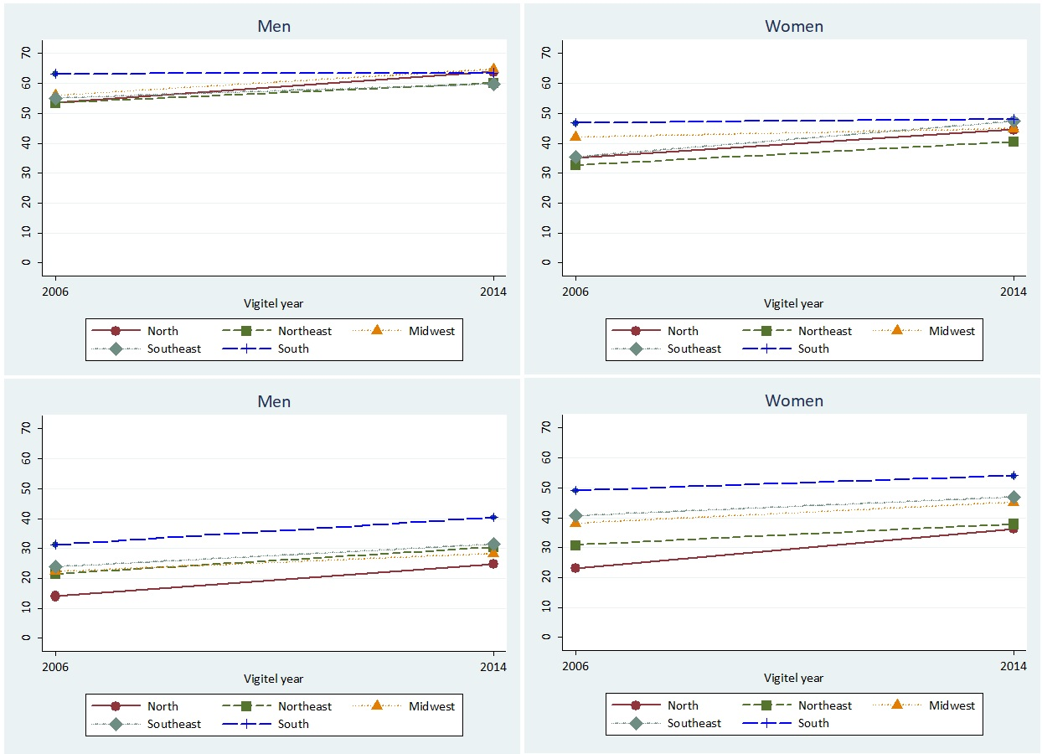
*p-value = 0.007
*p-value = 0.227
*p-value = 0.012
D
B
A
C
*p-value = 0.013
Supplementary figure 3. Prevalence of protective factors in Brazil according to geographical regions and stratified by gender (A - Prevalence of physical activity in men; B - Prevalence of physical activity in women; C - Prevalence of regular consumption of fruits and vegetables in men; D - Prevalence of regular consumption of fruits and vegetables in women).
*p-value for second order interaction between region and survey’s year.

